ASSIGNMENT NO. 10
7CS353 — Machine Learning Lab
Name: ATHARV T CHOUGULE
PRN: 245100024
Batch: T1
B1 Load Data and Establish a Baseline • Load the dataset. Perform required preprocessing. • Fit a default LogisticRegression(C=1.0, max_iter=1000) on the training set. Report: Accuracy, F1-score, ROC-AUC on the test set. This is your baseline. • In a Markdown cell: what does an AUC of 0.5 mean? What does 1.0 mean? What does your baseline AUC tell you?
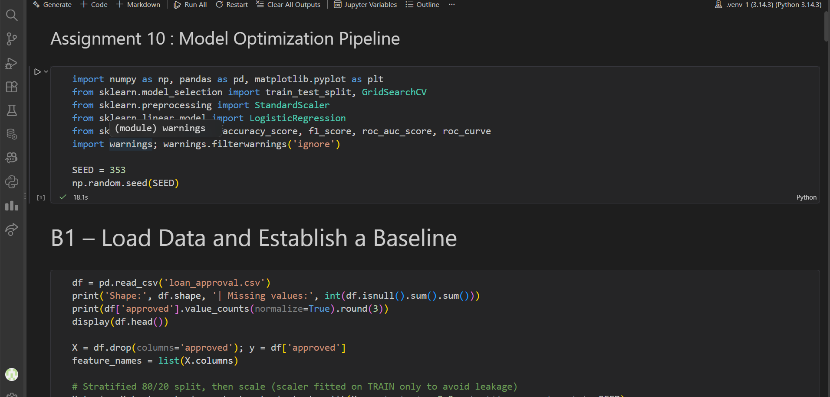
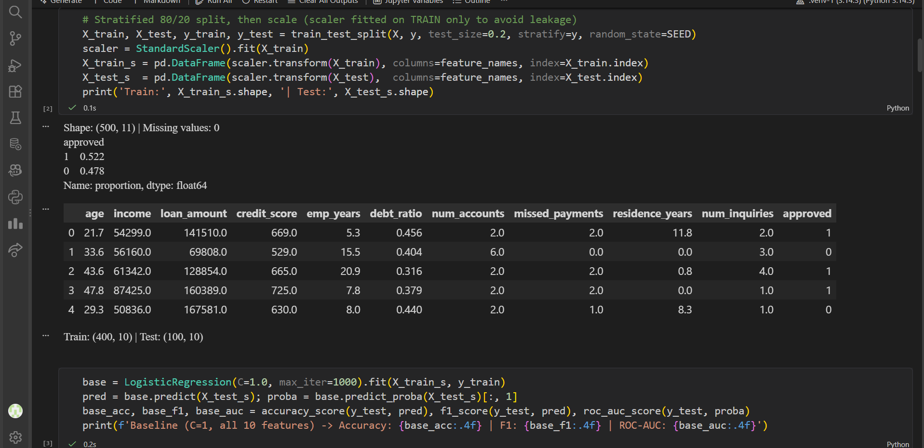
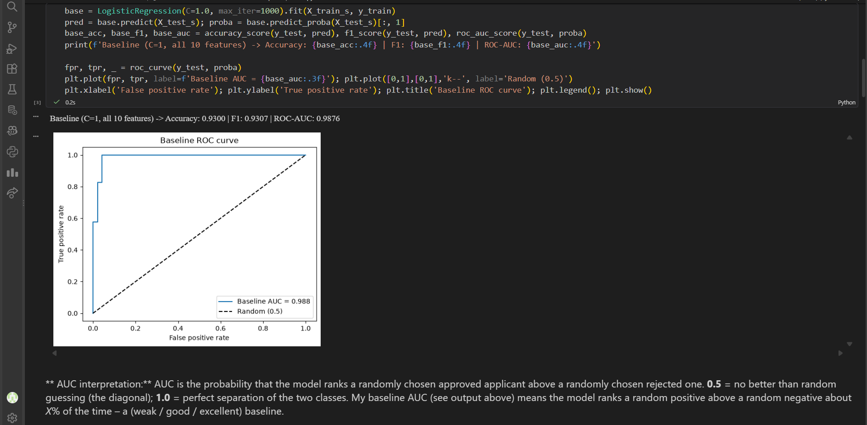

B2 Regularization — Ridge, Lasso, and ElasticNet :
B2.1 Fit three models on the training set: LogisticRegression with (a) penalty="l2" (Ridge), (b) penalty="l1", solver="liblinear" (Lasso), (c) penalty="elasticnet", solver="saga", l1_ratio=0.5. Use C=0.1 for all. Report test AUC for each.
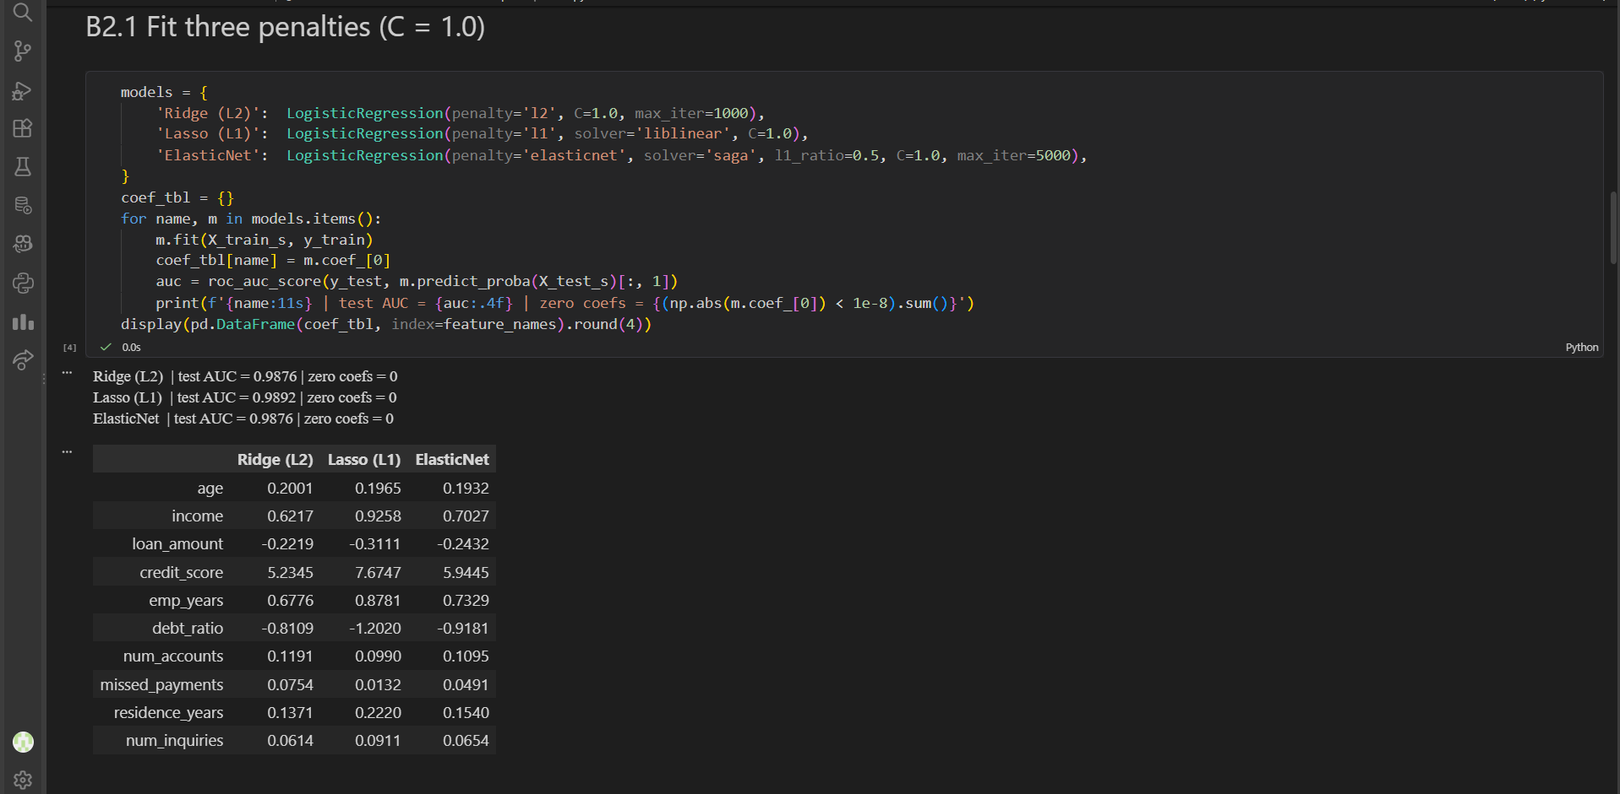
B2.2 Lasso regularization path: loop C over [0.001, 0.005, 0.01, 0.05, 0.1, 0.5, 1, 5, 10]. For each C, fit Lasso and record the 10 coefficients. Plot coefficient value vs log(C) — one line per feature. Which features reach zero first as C decreases?

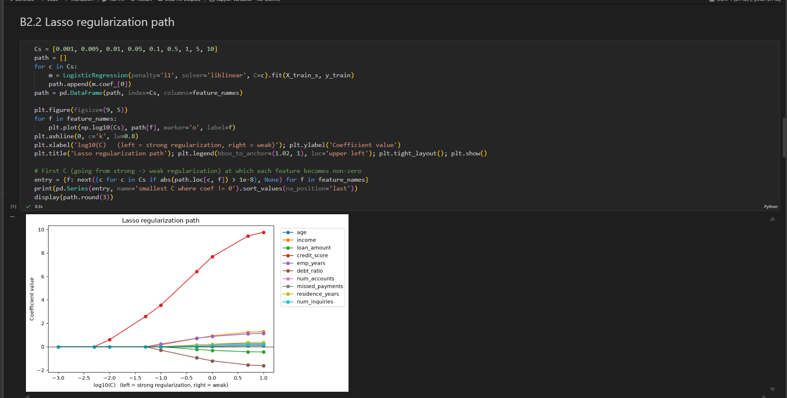
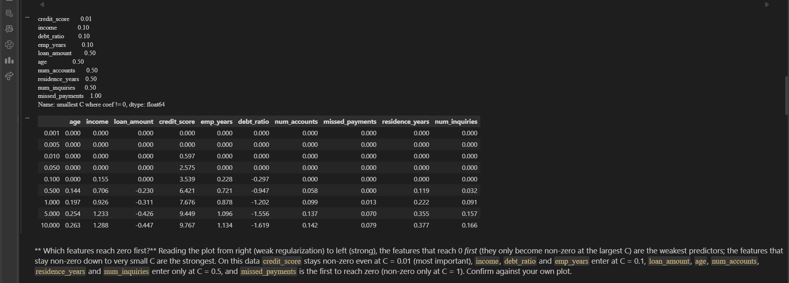
B2.3 Print a table: Feature | Ridge coef (C=0.1) | Lasso coef (C=0.1). How many features does Lasso zero out at C=0.1?

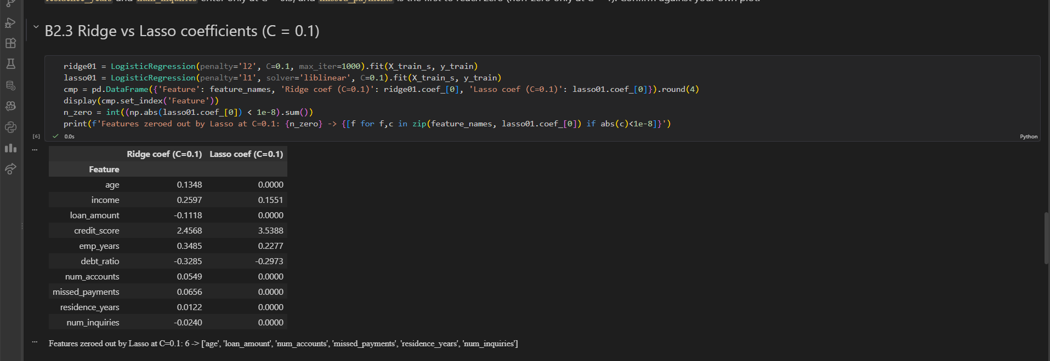
B2.4 Markdown: explain in 3 sentences why Ridge keeps all features while Lasso can zero some out. Relate your answer to the geometry of L1 vs L2 penalties.


B3 Feature Importance and Hyperparameter Tuning:

B3.1 Fit Lasso (C=0.1). Extract and sort features by |coefficient|. Plot a horizontal bar chart: feature names on y axis, |coef| on x-axis. Colour zero-coefficient features differently.
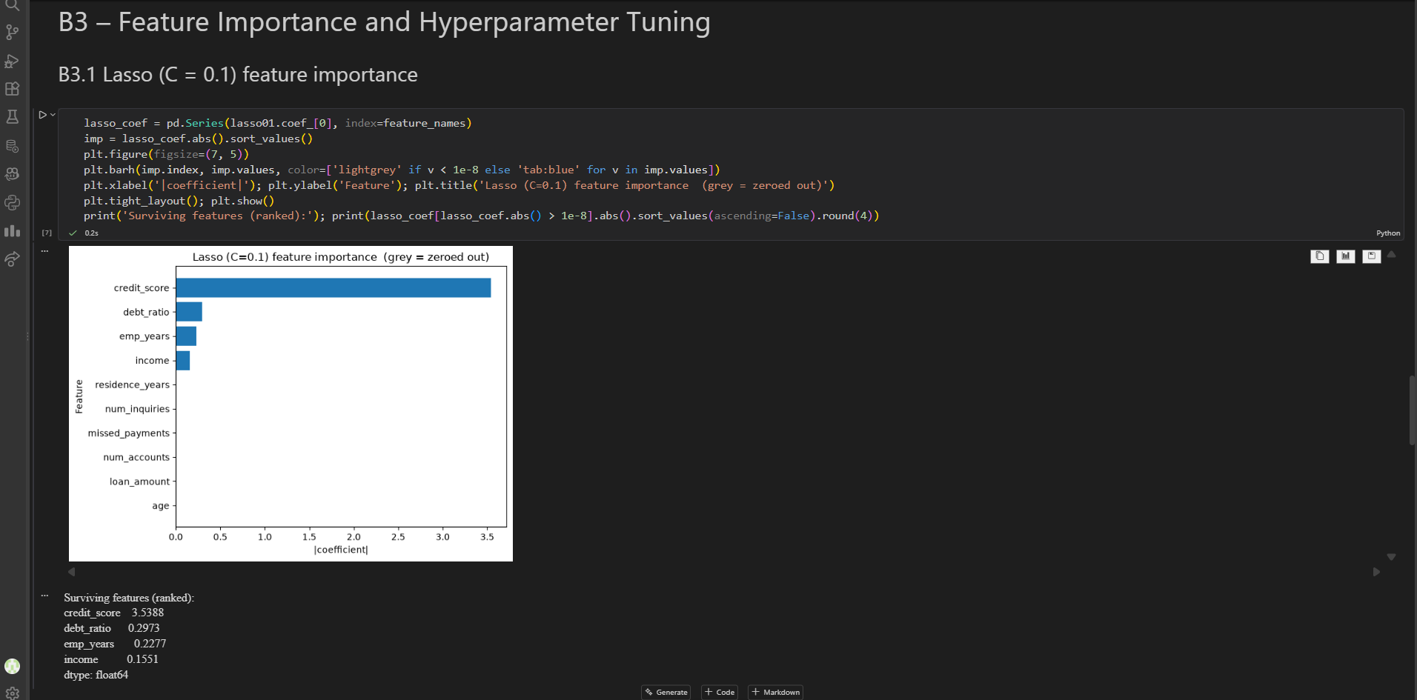
B3.2 Identify which features have coef = 0. Drop them from X_scaled. Call this X_reduced. Retrain the baseline LogisticRegression(C=1.0) on X_reduced. Report test AUC. Did dropping weak features hurt performance?
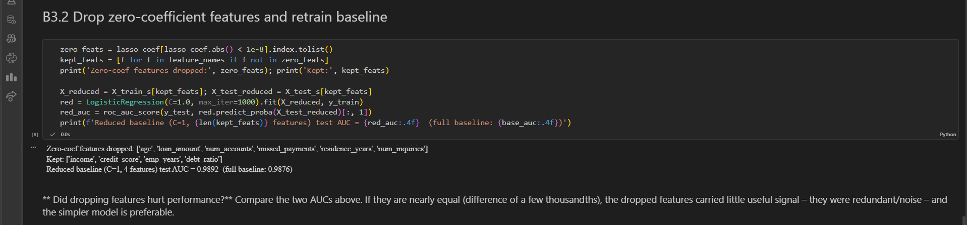
B3.3 GridSearchCV: on X_reduced, search C over [0.001, 0.01, 0.1, 1, 10, 100] with cv=5, scoring="roc_auc". Print best_params_ and best_score_.
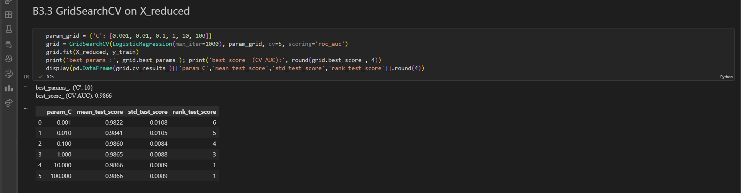
B3.4 Evaluate grid.best_estimator_ on the test set. Fill in this table with your results: | Model | Baseline (C=1, all features) | Lasso-reduced (C=1) | Tuned (best C, reduced) | Features used | Test AUC | | 10 | ??? | ??? | ??? | | ??? | | ??? |
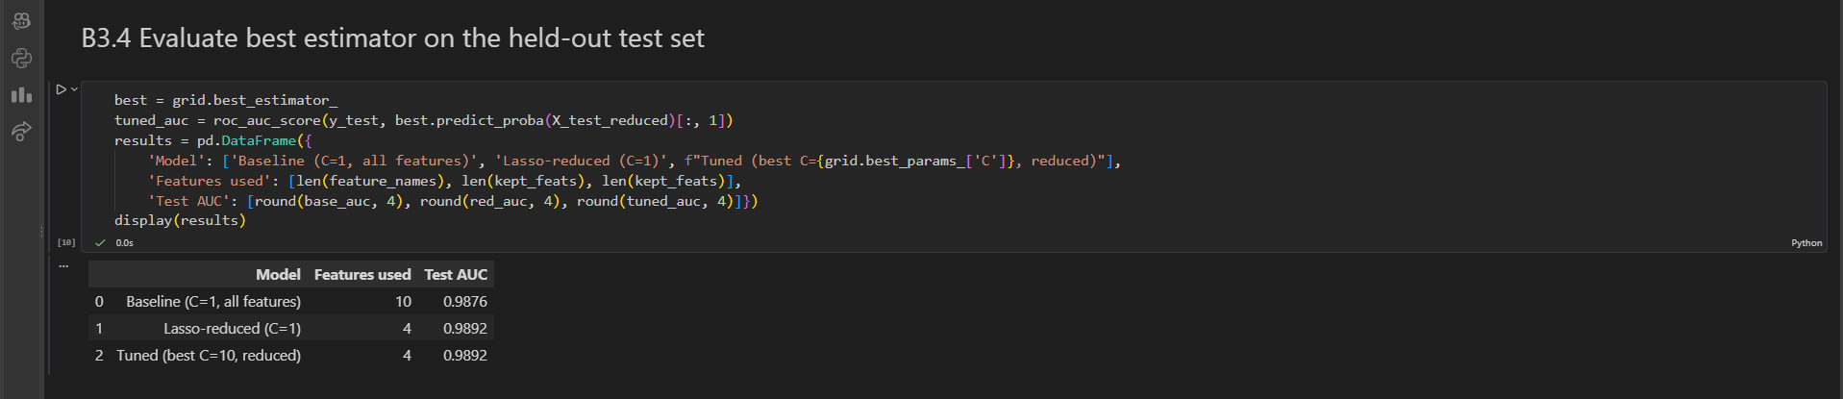
B4 Design Task — Real-World Adaptation :
B4.1 Select exactly 5 features. Justify your choice: why these 5? Use evidence from B2 (regularization path) and B3 (coefficient ranking).
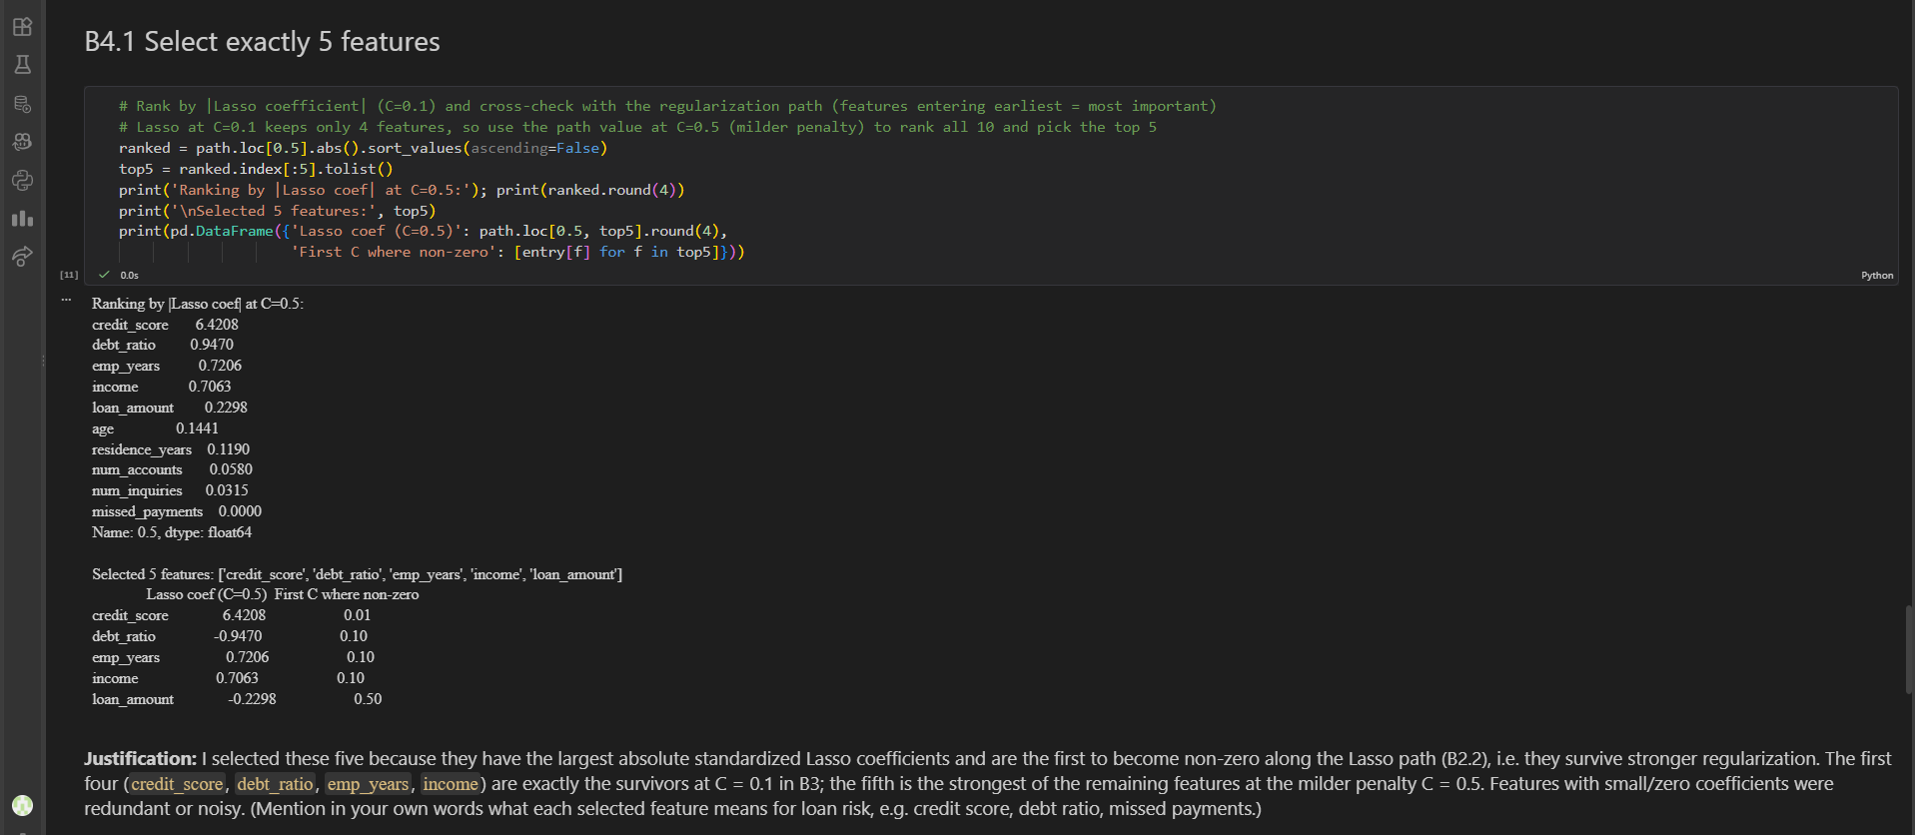
B4.2 Tune the regularization strength for your 5-feature model using GridSearchCV (same grid as B3.3). Report best C and test AUC.
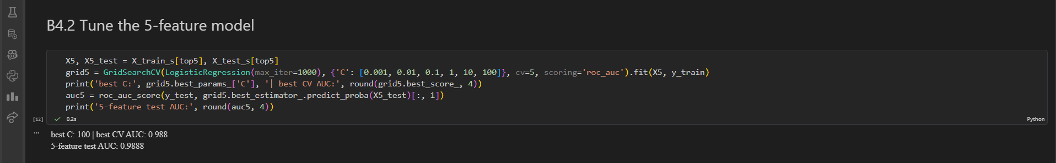
B4.3 Compute the AUC ratio: your 5-feature model AUC / baseline AUC × 100%. Does it meet the ≥90% constraint?
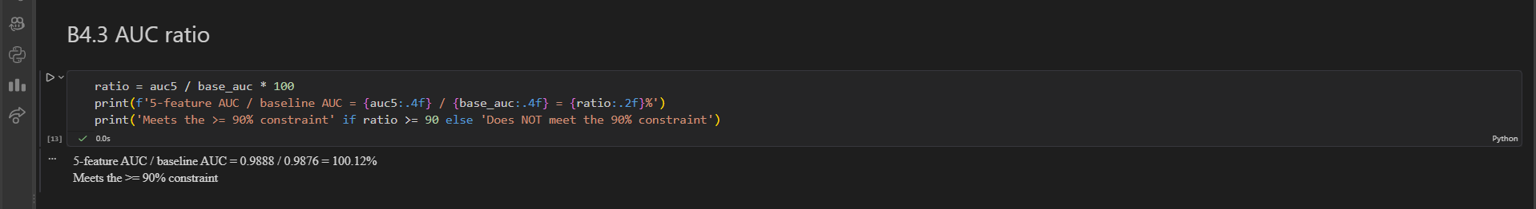
B4.4 Write a short design report (≥5 sentences in a Markdown cell) covering: (a) which features you selected and why, (b) which regularization method you used and why, (c) what you would do if the 90% constraint was not met, (d) one potential fairness concern with this model in a real bank.


